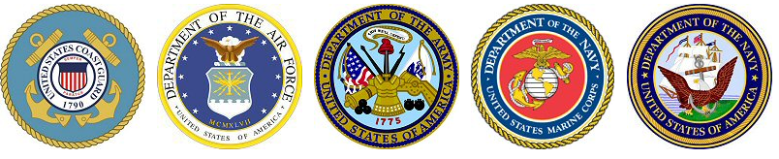
Military Visitation Schedule
~~ During Lunches in the center Cafeteria from 11:17 am – 1:32 pm ~~

AIR FORCE
1st Tuesday of the month | TSgt Casey VanVeckhoven
Glynn.Vanveckhoven@us.af.mil phone: 402-210-0640

ARMY
2nd Wednesday of the month | SSG Gene Thompson
gene.d.thompson8.mil@army.mil phone: 308-392-7093

MARINES
3rd Monday of the month | GySgt Wayne Stephan
wayne.stephan@marines.usmc.mil phone: 402-292-2477
Navy
3rd Thursday of the month | CS2 (SW) Daniel Grabenschroer
daniel.s.grabenschro@navy.mil phone: 402-575-0549

Nebraska Army National Guard
3rd Tuesday of the month | SPC Liz Contreras
lizbeth.tzompantzi-contreras.mil@army.mil phone: 402-618-0256

Military Service Academies
Lt. Col. Patrick Ryan, United States Air Force Academy | CDR Eric Taylor, United States Naval Academy
patrick.ryan@ops.org phone: 402-990-1890 | etaylor@1994.usna.com phone:858-729-8348

